There are 4 boards:

1. Smart Motor board -
   1. ESP8266 board is soldered on top
   2. Charging circuit
   3. Battery port & battery
   4. Sensor port
   5. Wio Terminal port (for training)
   6. Connection to Button board
2. Button board -
   1. Power button - that also switches between charging and discharging
   2. LED
3. Sensor board -
   1. A light sensor
4. Wio Terminal connection board -
   1. Connects to Wio Terminal

All files are here <https://drive.google.com/drive/folders/1v297oppk2PXFHODXI-IEtcNOhpGhWiWt>

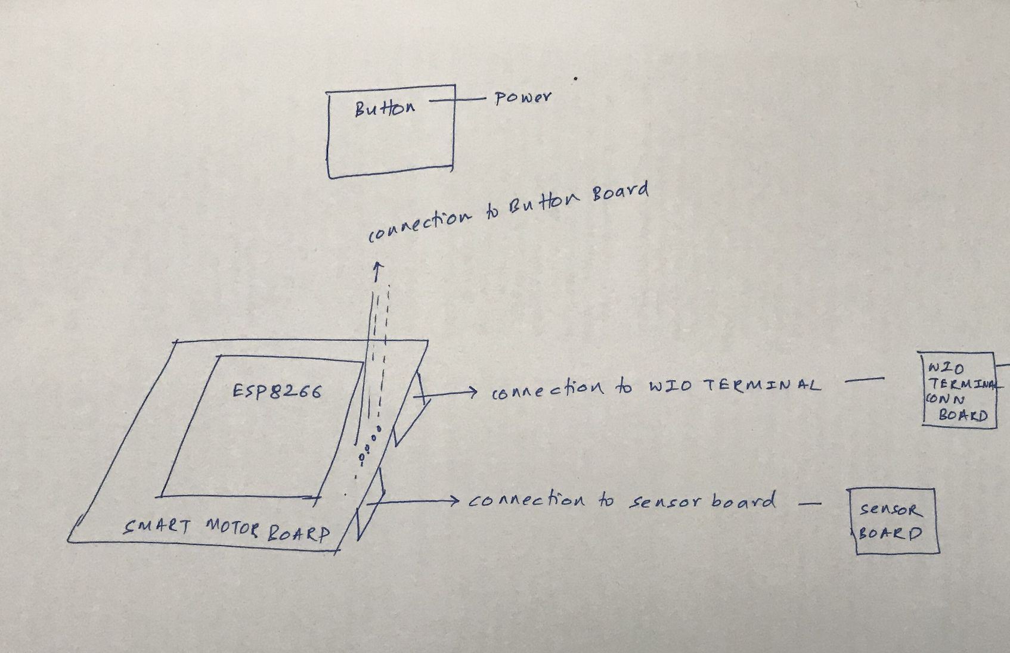

Smart Motor Board

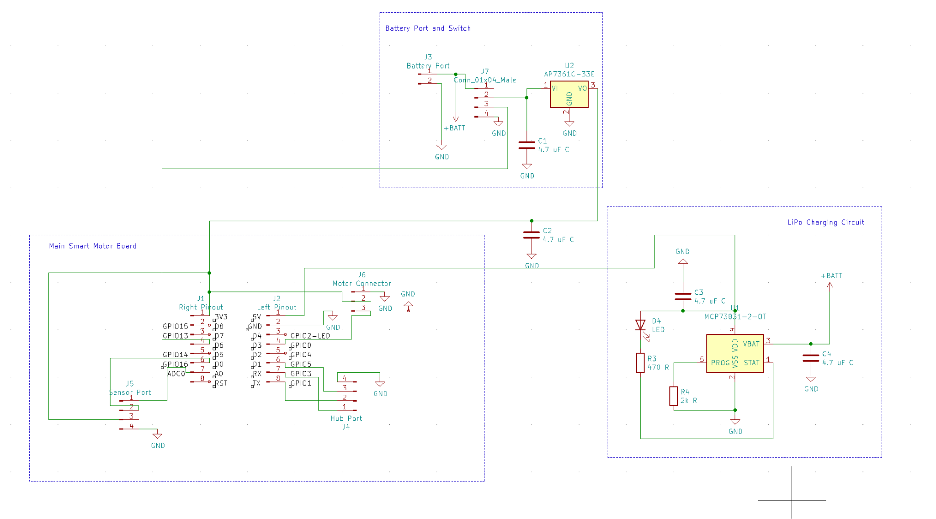

Button Board

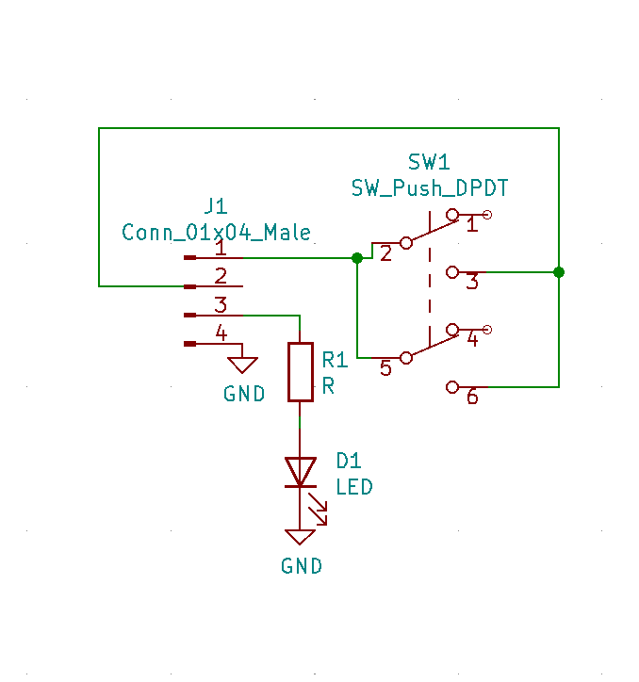

Light Sensor Board

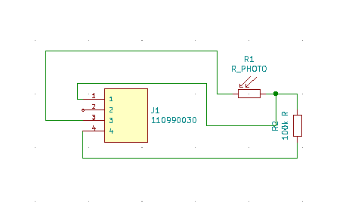

WIO Connection Board

